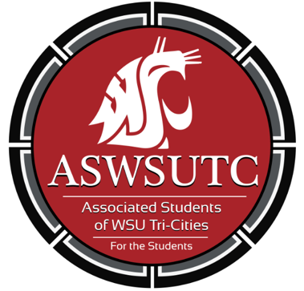

Associated Students of
Washington State University Tri-Cities

Senate Meeting
Agenda
September 5, 2018 | 8:00 AM
SUB 120N

- Introductions
- Additions, Deletions, and/or Clarifications to the Agenda
- Reading and Approval of Minutes
  - August 27th Minutes
- Unfinished Business
- New Business
  - Running start delegate
- Executive Updates
  - Stipends
  - Advocacy Excel spreadsheet
  - Best practices
  - Tabling
  - Inclusive language
  - Updates
- Senate Updates
- Director Update
- Advisor Updates
- Judicial Updates
- Staff Updates
- Open Forum & Announcements
- Adjournment

