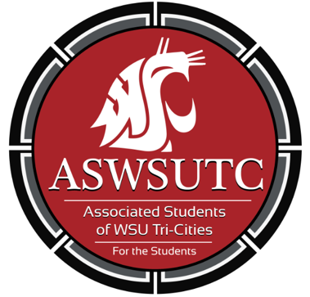

Associated Students of
Washington State University Tri-Cities

Senate Meeting
Agenda
September 26, 2018 | 8:00 AM
SUB 120N

- Introductions
- Additions, Deletions, and/or Clarifications to the Agenda
- Reading and Approval of Minutes
- Unfinished Business
- New Business
- Executive Updates
  - Policy Feedback
  - Library Design
  - Volunteers for the ballot drop box grand opening
  - Window Hours (be there on time and if you cannot make it notify your supervisor and try to find someone to cover)
  - Tabling
  - New Senate meeting time
- Senate Updates
- Director Update
- Advisor Updates
- Judicial Updates
- Staff Updates
- Open Forum & Announcements
- Adjournment

