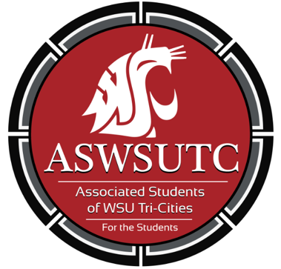

Associated Students of
Washington State University Tri-Cities

Senate Meeting
Agenda
September 19, 2018 | 8:00 AM
SUB 120N

- Introductions
- Additions, Deletions, and/or Clarifications to the Agenda
- Reading and Approval of Minutes
- Unfinished Business
- New Business
- Executive Updates
  - CIC Library
  - Campus Event Planning
  - First Right of Refusal
- Senate Updates
- Director Update
- Advisor Updates
- Judicial Updates
  - Voting
- Staff Updates
- Open Forum & Announcements
- Adjournment

