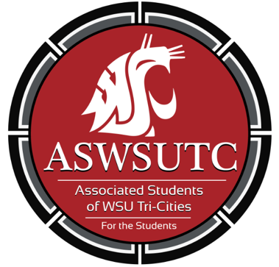

Associated Students of
Washington State University Tri-Cities

Senate Meeting
Agenda
September 12, 2018 | 8:00 AM
SUB 120N

- Introductions
  - Marie, Graduation Senator
  - Ashley, CAHNRS Senator
  - Taylor, Education Senator
  - Dani, Engineering Senator
  - Turner, Business Senator
  - Farha, University Senator
  - Anjhie, Nursing Senator
  - Sierra, Senate Pro-tempore
  - Christina, Judicial Board Member
  - Astrid, Director of Marketing
  - Akanna, Director of Legislative Affairs
  - Lian, Director of diversity affairs
  - Carter, Graphic Design
  - Remy, Executive Assistant
  - Zach, President
- Additions, Deletions, and/or Clarifications to the Agenda
- Reading and Approval of Minutes
  - September 5th Minutes
  - Taylor moves to approve minutes
  - Turner Seconds
  - All ayes (motion passes)
- Unfinished Business
- New Business
  - Taylor moves to table new business until Zach arrives
  - Turner seconds
  - Motion passes (all ayes)
  - Anjhie moves to lift the tabling
  - Taylor seconds
  - Motion passes (all ayes)
  - Student Leadership and Diversity
- Executive Updates
  - Student Leadership and Diversity: Taking Action on Campus and in Your Community! (This is a required training) Saturday, October 20, from 10:00 a.m. to 12:00 p.m. in SUB 120
  - No issues with Katie Banks Attendance- Dani would prefer if more professors attended
  - No issues with global leadership students attending
  - Ask everyone about having photo taken before hand/ Review photos once taken
- Senate Updates
  - Town hall meeting
    - Director didn’t show up, Dani used time to gather feedback regarding her program
- Director Update
  - Director of Diversity:
    - Heels to Heal Fundraiser
    - Undocuqueer Conference
      - 12 volunteers
  - Director of Legislative Affairs:
    - Healthcare for Cougs
      - Today at 11:30 and 1:30, teaches people what their healthcare laws are
- Advisor Updates
  - Coffee shop opens today
- Judicial Updates
  - Special Election Debates
    - Senate Debate 1:30pm
- Staff Updates
  - Marketing Request
- Open Forum & Announcements
  - Library sub-committee
    - What do you think would go best in the Library and student success center?
    - Dani Requests PDF in order to draw on the thing
    - Need to have idea of what do to for CIC Lib by next meeting
  - Campus Event Planning Guide
    - Cannot be sponsored by WSUTC unless signed off by the chancellor
    - A way to increase diversity on campus
  - First Right of Refusal
    - What is our insurance that the café will provide what we need on time and professionally?
    - On campus only/ off campus events will not be forced to use the café
- Adjournment
  - 8:58

