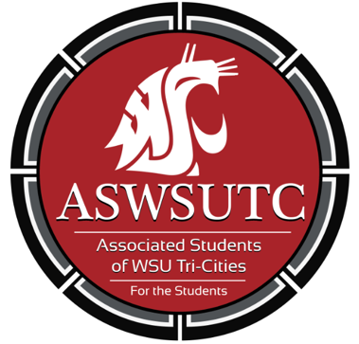

Associated Students of
Washington State University Tri-Cities

Senate Meeting
Agenda
September 12, 2018 | 8:00 AM
SUB 120N

- Introductions
- Additions, Deletions, and/or Clarifications to the Agenda
- Reading and Approval of Minutes
  - September 5th Minutes
- Unfinished Business
- New Business
  - Student Leadership and Diversity
- Executive Updates
  - Student Leadership and Diversity: Taking Action on Campus and in Your Community! (This is a required training) Saturday, October 20, from 10:00 a.m. to 12:00 p.m. in SUB 120
- Senate Updates
- Director Update
  - Director of Diversity:
    - Heels to Heal Fundraiser
    - Undocuqueer Conference
  - Director of Legislative Affairs:
    - Healthcare for Cougs
- Advisor Updates
- Judicial Updates
  - Special Election Debates
- Staff Updates
  - Marketing Request
- Open Forum & Announcements
  - Library sub-committee
  - Campus Event Planning Guide
  - First Right of Refusal
- Adjournment

