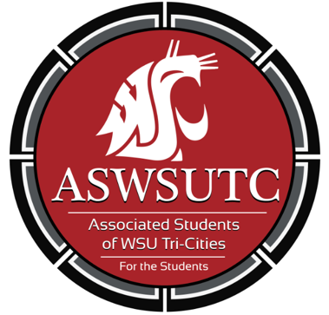

Associated Students of
Washington State University Tri-Cities

Senate Meeting

October 18, 2018 | 7:00PM
East 212

- Introductions
- Additions, Deletions, and/or Clarifications to the Agenda
- Reading and Approval of Minutes
  - October 11th Minutes
- Unfinished Business
  - Submission of questions to Dani
- New Business
- Discussions Items
- Executive Updates
  - Spring Schedules are due by November 16th (submit to Remy via email)
  - RFO Brown Bag: November 27th 12:00-1:00PM
  - International Student Potluck: October 26th 5:30-7:00PM
- Senate Updates
- Director Update
- Judicial Updates
- Staff Updates
- Advisor Updates
- Open Forum & Announcements
- Adjournment

