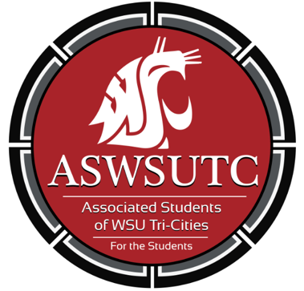

Associated Students of
Washington State University Tri-Cities

Senate Meeting

November 1, 2018 | 7:00PM
SUB 120 N

- Introductions
- Additions, Deletions, and/or Clarifications to the Agenda
- Reading and Approval of Minutes
  - October 18th Minutes
- Unfinished Business
  - Masculinity Speaking Engagement
- New Business
  - Web Governance Policy
- Discussions Items
- Executive Updates
  - Spring Schedules are due by November 16th (submit to Remy via email)
  - RFO Brown Bag: November 27th 12:00-1:00PM
    - Reply to calendar invite
  - Spring Orientation volunteers – Jan 4
    - See sign-up sheet
  - WAC Proposed Changes Hearing – Nov 6
  - Men’s Health Promotion – Nov 2
  - Preview Days – Nov 3 (this Saturday)
    - See sign-up sheet
    - 8:30am – 12:00pm
    - Also Nov 17
  - Calendar Invites – Respond to them
  - Advocacy Sheet Updates
    - They should be up to date
  - Bi-Weekly meetings with advocacy group
    - See sign-up sheet
- Senate Updates
- Director Update
- Judicial Updates
  - Office being cleaned this Friday (I have yet to get confirmation, but I sent in the request)
  - I have received 6 responses for the next semesters schedule google poll so “FILL OUT POLL”
- Staff Updates
- Advisor Updates
- Open Forum & Announcements
- Adjournment

