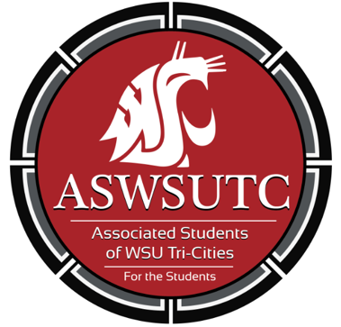

Associated Students of
Washington State University Tri-Cities

Senate Meeting

August 15th 2018 | 10:15-10:45AM
SUB 120N

- Introductions
- Additions, Deletions, and/or Clarifications to the Agenda
- Reading and Approval of Minutes
  - July Minutes
- Unfinished Business
- New Business
  - Confirmation Hearings
    - Graphic Designer
    - Finance Manager
    - Director of Diversity Affairs
  - Selection Hearing
    - University Senator
  - Approve Election Calendar
  - Title IX Resolution
  - By-Law Bill #9
- Executive Updates
  - Committee Updates
    - Academic Building Committee
    - Governance Board
    - Title IX/Housing Committee
    - 5 Year Plan Presentation
- Senate Updates
- Director Updates
- Staff Updates
- Advisor Updates
  - Some Updates Maybe
- Open Forum & Announcements
  - Submit Office Hours and Bio’s
- Adjournment

