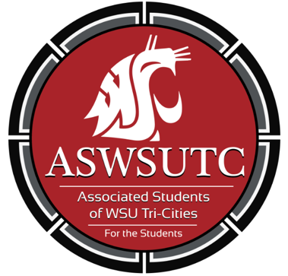

Associated Students of
Washington State University Tri-Cities

Senate Meeting
Agenda
October 3, 2018 | 8:00 AM
SUB 120N

- Introductions
- Additions, Deletions, and/or Clarifications to the Agenda
- Reading and Approval of Minutes
  - September 26 Minutes
- Unfinished Business
- New Business
  - S&A Committee Senator
- Discussion Item
  - Policy Feedback
    - BPPM 70.31
    - BPPM 45.42
    - BPPM 30.82
    - BPPM 30.30
    - BPPM 20.42
- SUB Cleanliness Update
- Library Design
- Service Week: October 15th -19th
- Executive Updates
- Ballot Drop Box Grand Opening: October 5th 2:00PM CIC Lawn
- Student Forum: October 4th 1:10-2:10 SUB 120N
- New senate time
- Senate Updates
- Director Update
- Advisor Updates
- Judicial Updates
- Staff Updates
- Open Forum & Announcements
- Adjournment

