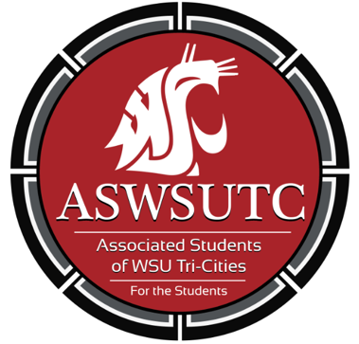

Associated Students of
Washington State University Tri-Cities

Senate Meeting
Agenda

October 11, 2018 | 7:00 PM
SUB 120N

- Introductions
- Additions, Deletions, and/or Clarifications to the Agenda
- Reading and Approval of Minutes
  - October 3rd Minutes
- Unfinished Business
- New Business
- Discussion Item
  - WAC Changes
- Executive Updates
  - Abstentions
  - Bi-Weekly Advocacy Meetings
  - Advocacy work presentations
  - Tabling Schedule
  - Submit your events to the Coug Sync Calendar
- Senate Updates
  - Surveys
- Director Update
- Advisor Updates
- Judicial Updates
- Staff Updates
  - Market Request
- Open Forum & Announcements
- Adjournment

