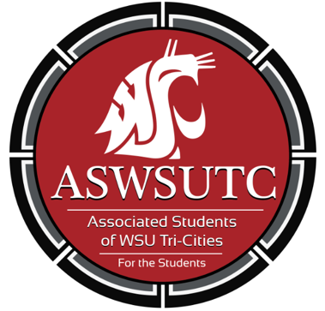

Associated Students of
Washington State University Tri-Cities

Finance Committee Meeting

September 19| 9:00 pm
Student Union Building 120N

- Introductions
- Additions, Deletions, and/or Clarifications to the Agenda
- Reading and Approval of Minutes
  - 9/12/18
- Unfinished Business
- New Business
  - Swing Dance Club
  - MEChA
  - Patriots’ Club
  - Gaming Club
- Open Forum
- Announcements
- Adjournment

