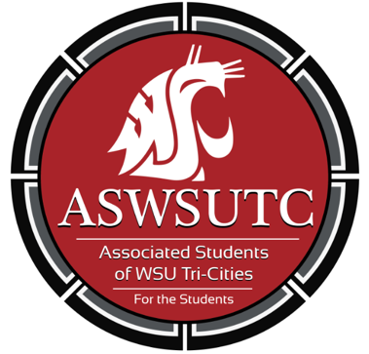

Associated Students of
Washington State University Tri-Cities

Finance Committee Meeting

November 28| 9:00 am
Student Union Building 120N

- Introductions
- Additions, Deletions, and/or Clarifications to the Agenda
- Reading and Approval of Minutes
  - 10/31/18
- Unfinished Business
- New Business
  - ASCE
  - Psychology Club
  - Coding Cougs
  - Coug Wine Society
- Open Forum
- Announcements
- Adjournment

