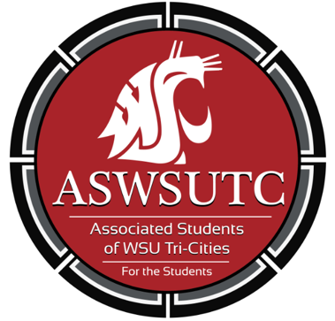

Associated Students of
Washington State University Tri-Cities

Finance Committee Meeting

October 3| 9:00 pm
Student Union Building 120N

- Introductions
- Additions, Deletions, and/or Clarifications to the Agenda
- Reading and Approval of Minutes
  - 9/26/18
- Unfinished Business
- New Business
  - World Research Club
  - Coug Wine Society
  - Coding Cougs
  - Robotics Club
- Open Forum
- Announcements
- Adjournment

