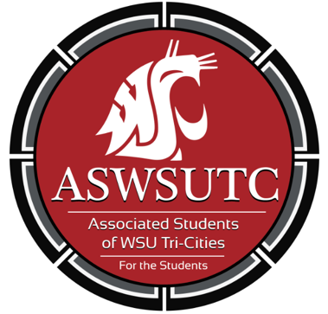

Associated Students of
Washington State University Tri-Cities

Finance Committee Meeting

October 24| 9:30 am
Student Union Building 120N

- Introductions
- Additions, Deletions, and/or Clarifications to the Agenda
- Reading and Approval of Minutes
  - 10/17/18
- Unfinished Business
- New Business
  - Coug Wine Society
- Open Forum
- Announcements
- Adjournment

