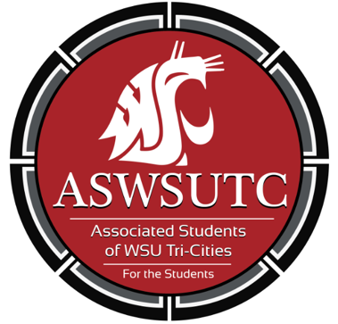

Associated Students of
Washington State University Tri-Cities

Finance Committee Meeting

August 22nd | 9:00 am
Student Union Building 120N

- Introductions
- Additions, Deletions, and/or Clarifications to the Agenda
- Reading and Approval of Minutes
- Unfinished Business
- New Business
  - Funding request process
  - Policies
  - Chair selection
  - Vice chair selection
- Executive Updates
- Open Forum
- Announcements
- Adjournment

