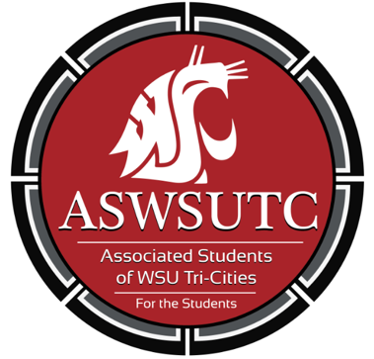

Associated Students of
Washington State University Tri-Cities

Senate Meeting
Minutes
August 27, 2018 | 8:05 AM
SUB 120N
- Introductions
  - Savanna, Vice President
  - Marie, Graduation Senator
  - Ashley, CARHRS Senator
  - Taylor, Education Senator
  - Dani, Engineering Senator
  - Turner, Business Senator
  - Farha, University Senator
  - Anjhie, Nursing Senator
  - Sierra, Senate Pro-tempore
  - Christina, Judicial Board Member
  - Astrid, Director of Marketing
  - Akanna, Director of Legislative Affairs
  - Lian, Director of diversity affairs
  - Carter, Graphic Design
- Additions, Deletions, and/or Clarifications to the Agenda
  - Sierra moves to switch finance confirmation before the SEB Introduction
  - Taylor seconds
  - Motion passes (all ayes)
- Reading and Approval of Minutes
  - August 22nd minutes
  - Taylor motions to approve the minutes
  - Dani Seconds
  - Motion passes (all say ayes)
- Unfinished Business
- New Business
  - SEB Introduction
    - Dani moves to table this until after discussion items but before updates
    - Taylor seconds
    - Motion passes (all say ayes)
    - Jessica is the Graphic Designer for SEB
  - Finance manager confirmation
    - Makayla, shares about herself and her background in student government
    - Taylor moves to confirm Makayla as the Finance manger
    - Marie seconds
    - Motion passes (all ayes)
- Executive Updates
  - Agenda Deadline 2PM Monday before the meeting.
  - WSA- this past weekend
    - Akanna has the legislation if anyone is interested
- Senate Updates
- Director Update
  - Lian is still working on getting on committees
  - Astrid is posting photos of information regarding the team on facebook
- Advisor Updates
  - Ian is still working on the coffee shop
    - Punch cards, bring your own mug discount, “gift cards” for the coffee shop opening
- Judicial Updates
  - 2 people have filed for election, closes on Wednesday
- Staff Updates
  - Window hour Thursday’s 4-5PM
- Open Forum & Announcements
  - Tuition Free VS Debt Free College Discussion
    - Tuition free- only tuition
      - More students would be benefited through this plan
      - Middle class/ upper middle class, may be detrimental to low class as they need more help than just tuition
    - Debt Free- Cost of attendance
      - All students?
  - Instate VS Out of State Discussion
    - Out of State students
      - Out of state and international students
    - Instate Students
      - This includes DACA students (if residents of Washington states)
      - Washington State Students
  - Running Start Delegate Discussion
    - Dani moves to table this discussion to the next meeting and move forward with the SEB into
    - Turner seconds
    - Motion passes (all say aye)
- Adjournment
  - Sierra moves to adjourn
  - Taylor Seconds
  - Motion passes (all say aye)
  - 8:48

