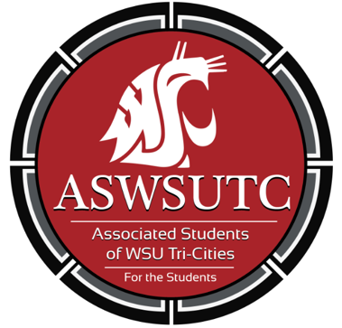

Associated Students of
Washington State University Tri-Cities

Finance Committee Meeting

August 29 | 9:00 pm
Student Union Building 120N

- Introductions
- Additions, Deletions, and/or Clarifications to the Agenda
- Reading and Approval of Minutes
  - 8/22/18
- Unfinished Business
- New Business
  - Procedure and Policies
  - Question and Concerns
- Executive Updates
- Open Forum
- Announcements
- Adjournment

