

TCH_LRN 490
Pre-Internship for Elementary Education

A Guide for Teacher Candidates


The College of Education contributes to the theory and practice of the broad field of education and dedicates itself to understanding and respecting learners in diverse cultural contexts. We facilitate engaged learning and ethical leadership in schools and clinical settings. We seek collaboration with diverse constituencies, recognizing our local and global responsibilities to communities, environments, and future generations.

Dr. John Mancinelli
Field Services Director
WSU Tri-Cities Office of Field Services
WSU Tri-Cities

O: 509-372-7237
E: John.mancinelli@wsu.edu
Tricities.fieldservices@wsu.edu

Contents
Contents
Welcome! 5
WSU Tri-Cities Field Services Team 6
What is the purpose of field experiences? 6
Who does your team consist of? 6
The Mentor Teacher 6
The Program Coordinator 7
The Field Supervisor 7
The Seminar Faculty 7
Required Clearances for Field Experiences 8
OSPI Background Checks 8
Washington and FBI Fingerprint Clearance 8
Liability Insurance 8
The Pre-Internship Field Experience 9
Pre-Internship Practicums 9
Courses 9
Teacher Candidate Activities 9
Teacher Candidate Tasks 11
Suggested Timeline 11
Evaluation: Professional Dispositions Evaluation for Field Experiences 11
Appendix A: Fall 2024 Deadlines 13
Appendix B: Topics for Discussion 14
Recommended Topics 14
Appendix C: Instructional Frameworks 17
School District List 17
Danielson 17
Marzano 17
CEL5D+ 17
Appendix D: Observation Tools 18
Appendix E: Pre-Internship Professional Dispositions Evaluation for Field Experiences (PI-PDEFE) 25
Appendix F: WSU Field Services 26
WSU Tri-Cities 26
WSU Pullman 26
College of Education Leadership 27




Welcome!
Dr. John Mancinelli WSU Tri-Cities Field Services Director John.mancinelli@wsu.edu

We are pleased to have you as part of the WSU College of Education's next generation of highly effective educators.
You are well on your way to becoming a teacher! School districts from Washington State voluntarily host our teacher candidates because they desire to partner in developing excellent teachers.
Your program coordinators work diligently to remind you about requirements and deadlines. The mentor teachers volunteer to open their classrooms to you as a teacher candidate. The field Supervisors look forward to guiding you through the maturation process of becoming a professional educator. The Field Services Office spends hours coordinating placements, clearances, and training. In short, many people make a great effort to give you field experiences!
As a teacher candidate, you will receive encouragement, coaching, modeling, and guidance throughout the process.
Please use this handbook and refer to it often during your early practicum field experiences.

WSU Tri-Cities Field Services Team









Dr. Judy Morrison  Academic Director  509-372-7176  jamorrison@wsu.edu | Dr. Lindsay Lightner  Alternative Route Academic Coordinator 509-372-7366  llightner@wsu.edu | Mr. Chris Gana  Traditional/MIT Academic Coordinator 509-742-7474  cgana@wsu.edu | Ms. Catherine Denham  Field Services Program Coordinator 509-372-7135  Catherine.denham@wsu.edu

What is the purpose of field experiences?
The act of teaching is an art form! Many moving parts of teaching are sophistically integrated. This type of professional practice requires hands-on learning in an actual classroom. There is no substitute for this type of learning, and it is valuable for creating highly effective teachers.
WSU's field experiences allow the teacher candidates opportunities to apply their newly acquired skills and knowledge found in their coursework. Applying knowledge and skills is often 'messy' and holds unique challenges. Field experiences allow this 'messy' process to occur with guidance from an expert mentor and field supervisor that transforms the 'messiness' into a competent educator.

Who does your team consist of?

The Mentor Teacher
Each school district handles the assignment of mentor teachers differently. However, all individuals serving as a mentor teacher must possess the following qualifications:
- Successful teaching for at least three years.
- Washington State Certified.
- Demonstrate effective instruction, classroom management, assessment, communication, and teamwork as determined by the school district.
- Be willing to work with a teacher candidate and complete paperwork and evaluations.
- Be willing to model effective professional behaviors and practices for a teacher candidate.

The Program Coordinator
Each teacher preparation program has a coordinator who works closely with WSU students to help facilitate the completion of graduation and certification requirements. If you have programmatic questions, please feel free to direct them to contact:
  - Field Services Program Coordinator, Ms. Catherine Denham O: 509-372-7135 E: catherine.denham@wsu.edu
  - Alternative Route Program, Dr. Lindsay Lightner O: 509-372-7366 E: llightner@wsu.edu
  - Undergraduate or MIT Programs, Mr. Chris Gana O: 509-742-7474 E: cgana@wsu.edu

The Field Supervisor
The University field supervisor represents the university program to our partner K-12 schools. The field supervisor is an instructor, advisor, coach, and evaluator for the teacher candidate and a resource and support person for the mentor teacher.
The field supervisor is in close contact with building personnel, the district coordinator, the WSU Tri-Cities Field Services Director, and the WSU Pullman Office of Field Services and Certification. Field supervisors are frequently called upon to clarify the university program requirements, eliminate misunderstandings, or resolve conflicts between the mentor teacher, School District, and the teacher candidate. Most field supervisors possess years of teaching, and many also have years of administrative experience. This experience is a valuable resource for the entire team. The field supervisor is evaluated and reports to the Field Services Director. The field supervisor has the authority to work with the school district, principal, and mentor teacher to adapt the field experience to meet the needs of all parties.
The field supervisor evaluates teacher candidate performance and approves all final documentation.

The Seminar Faculty
Concurrent with the field experience, teacher candidates take a seminar course focusing on the field experience. In a seminar, teacher candidates share experiences and problem-solve issues they face. Additionally, they receive training on pedagogical strategies and high-value educational practices. Each seminar has assignments the teacher candidate is expected to complete in their field experience.
  - TCH_LRN 401 - Bilingual/English Language Learners (6 hrs/wk, 90 hrs total)
    - Dr. Eric Johnson (e.johnson@wsu.edu) 509-372-7304
  - TCH_LRN 402 - Instructional Strategies, Literacy, Technology, and Assessment (3 hrs/wk, 45 hrs total)
    - Dr. John Mancinelli (john.mancinelli@wsu.edu) 509-372-7237
  - TCH_LRN 405 - Math and Science (3 hrs/wk, 45 hrs total)
    - Dr. Judy Morrison (jamorrison@wsu.edu) 509-372-7176
  - TCH_LRN 590 - MIT content experience (16 hrs/wk, 210 hrs total)
    - Dr. John Mancinelli (john.mancinelli@wsu.edu) 509-372-7237
  - SPEC_ED 490 - Special Education (6 hrs/wk, 90 hrs total)
    - Yun-Ju Hsiao (yhsiao@wsu.edu) 509-372-7505
  - TCH_LRN 490/MIT 571 – Pre-Internship (16 hrs/wk, 210 hrs total)
    - Dr. Lindsay Lightner (llightner@wsu.edu) 509-372-7366
  - TCH_LRN 415/MIT 575 – Student Teaching Internship (40 hrs/wk, ~600 hrs total)
    - Dr. John Mancinelli (john.mancinelli@wsu.edu) 509-372-7237

Required Clearances for Field Experiences

OSPI Background Checks
The Washington Office of Superintendent of Public Instruction (OSPI) requires that all background checks are approved before all field experiences occur. Updated information about the process is kept here: https://education.wsu.edu/backgroundclearance/
Complete the online application for the pre-residency. When completed, OSPI’s database will reflect your status. You will be informed of the approval via the email you enter. The Field Services office will periodically check your clearance status and notify you if it is not approved. You will not be allowed to begin your field experience until the pre-residency is approved.

Washington and FBI Fingerprint Clearance
Complete the fingerprinting process as outlined (https://education.wsu.edu/backgroundclearance/). Since the ESD 123 tends to process fingerprinting approvals quicker than local law enforcement agencies, we recommend making an appointment with ESD 123 (Tri-Cities) as soon as possible.

Liability Insurance
Purchase liability insurance. You must have an insurance policy active the entire time you are placed in a field experience. Follow the guidelines (https://education.wsu.edu/undergradprograms/teachered/roadmap/liabilityinsurance/) to purchase insurance. Please send the email receipt that shows your expiration date.

The Pre-Internship Field Experience

Pre-Internship Practicums
The Pre-Internship courses prepare the teacher candidate for student teaching. Teacher candidates gain increased time in the field with increased responsibilities. Teacher candidates are placed with a mentor teacher at the beginning of the semester (August/January). They attend any orientations and professional development that the district may require before the beginning of the school year and assist with setting up the classroom. Supervisors visit/observe at least twice during the experience – an initial visit of introduction and expectations, and a second visit to observe a lesson and conference with the Mentor Teacher and jointly complete the Professional Dispositions Evaluation for Field Experiences (PDEFE). The candidate will complete assignments as detailed in the handbooks available at:
http://www.education.wsu.edu/field/
The Teacher Candidate will turn in all the signed and completed paperwork directly to the Field Services office; The mentor teacher should share concerns as they emerge with the teacher candidate and with the Field Supervisor.

Courses
- TCH_LRN 490 – Elementary Pre-Internship (210 hrs. total; 16 hrs./week)
- MIT 571 – Masters in Teaching Pre-Internship (210 hrs. Total; 16 hrs./week)

Alternative Route Program
Alternative Route (AR) Program Teacher Candidates follow a schedule arranged between the school district and WSU Tri-Cities to accommodate the paraeducators' work schedules and classroom/staffing needs. Alternative Route teacher candidates complete 210 hours of internship work embedded in their jobs as much as possible; how these hours are distributed may differ from 16 hours/week as arranged.

Teacher Candidate Activities
This is a summary overview. For details, please refer to the specific syllabus or handbook (T&L 490, MIT 571).
- Weekly Calendar Coordination: Teacher candidates are expected to review and have their calendar approved by their mentor teacher each week in advance using the log sheet to document. The mentor teacher should approve absences or alterations to the regular weekly schedule. The teacher candidate must inform the Field Supervisor of any scheduled absences or changes in the teacher candidate's schedule. Log sheets must always be current and are subject to review by the mentor teacher or field supervisor upon demand.
- Observation and Reflection: Teacher candidates are expected to make detailed observations primarily of their mentor teacher, paraeducators, instructional specialists, peer teachers, and specialists (music, art, PE, library). Reflections should focus on how the teacher candidate, as a teacher, interacts and utilizes the partnerships with these personnel.
- Lesson planning and leading instruction
  - Teacher candidates will design and lead a 50 to 60-minute classroom lesson a minimum of two times throughout the semester (ideally more).
  - Teacher candidates will coordinate the field supervisor and mentor teacher’s observations of these lessons.
  - Teacher candidates will use the College of Education Lesson Plan Template and any other paperwork required in their seminar.
  - The teacher candidate will provide the field supervisor and mentor teacher with a formal lesson plan using the College of Education Lesson Plan Template and any other materials required by their seminar a minimum of 24 hours before the instructional activity is scheduled.
- Observation Feedback
  - Teacher candidates expect a minimum of four observations by the field supervisor with two written feedback forms. There can be more; however, the teacher candidate will keep two written feedback observations to submit with their final paperwork.
  - Teacher candidates expect a minimum of four observations by the mentor teacher with two written feedback forms. There can be more observations with written feedback; however, the teacher candidate will keep two written feedback observations to submit with their final paperwork. Specific forms are not expected. Templates are provided in this handbook, however, if desired for use.
- PI-PDEFE Mid-Term Summary: The teacher candidate will summarize their work for each disposition in a single paragraph. The teacher candidate will submit the summary to their field supervisor and mentor teacher one week before the mid-term evaluation. The teacher candidate intends to demonstrate reflective practices through their documentation.
- PI-PDEFE Mid-Term Evaluation: The mentor teacher provides a short narrative in each of the ten (10) dispositions to the field supervisor one week before mid-term. Additionally, the mentor teacher and field supervisor will collaborate on scoring each of the ten dispositions as "Met," "Approaching," and "Not Met." The field supervisor will schedule a conference to review the PDEFE before the mid-term due date. The teacher candidate will collect the signed forms and submit them to their field supervisor by the deadline in .PDF format.
- PI-PDEFE Final Summary: The teacher candidate will summarize their work for each disposition in a single paragraph adding to the mid-term summary. The teacher candidate will submit the summary to their field supervisor and mentor teacher one week before the final evaluation. The teacher candidate intends to demonstrate reflective practices through their documentation.
- PI-PDEFE Final Evaluation: The mentor teacher provides a short narrative in each ten (10) dispositions to the field supervisor one week before the final deadline. Additionally, the mentor teacher and field supervisor will collaborate on scoring each of the ten dispositions as "Met," and "Not Met." The field supervisor will schedule a conference to review the PDEFE before the final due date. The teacher candidate will collect the signed forms and submit them to their field supervisor by the deadline in .PDF format.
- Final Packet: Checklists/Cover Sheet (Teacher-Candidate)
  - Log Sheet
  - Context for Learning (Teacher-Candidate)
  - Exit Survey (will be sent to you via WSU email from Pullman)
  - 2 University Field Supervisor Observations (provided by the Supervisor)
  - 2 Mentor Teacher Observations (provided by the Mentor-Teacher)
  - PI-PDEFE Final Evaluation (provided by Supervisor and Mentor-Teacher)

Teacher Candidate Tasks
Practicum Level | Teacher Candidate Tasks
Pre-Internship (T&L 490, MIT 571) | - Weekly log sheet signoff  - Submission of 4 lesson plans to mentor teacher and field supervisor  - Mid-term PI-PDEFE Evaluation  - Final PI-PDEFE Evaluation

Suggested Timeline
- Week 1 or 2: Meet with the mentor teacher and field supervisor to review practicum expectations, resources, timelines, and deliverables. Create weekly teaching schedule with the mentor teacher to arrange attendance schedule, observation dates, and times. Schedule observations for the term with the mentor teacher and field supervisor.
- Week 2-6: Observe weekly teaching schedule and use provided feedback to adjust teaching.
- Week 7: Send an email to the field supervisor with the mentor's narrative and score for each of the ten (10) PI-PDEFE dispositions. Schedule mid-term conversation with the mentor teacher and field supervisor.
- Week 8: Meet with the mentor teacher and field supervisor to review the mid-term PI-PDEFE. Sign the mid-term log sheet and PI-PDEFE, have mentor teacher and field supervisor sign needed documents, and send to field supervisor in PDF format.
- Week 9 – 14: Observe weekly teaching schedule and use provided feedback to adjust teaching.
- Week 15: Send an email to the field supervisor with the mentor's narrative and score for each of the ten (10) PI-PDEFE dispositions. Schedule final conversation with the mentor teacher and field supervisor.
- Week 16: Meet with the mentor teacher and field supervisor to review the final PI-PDEFE. Sign the final log sheet and PI-PDEFE, have mentor teacher and field supervisor sign needed documents, and send to field supervisor in PDF format.

Evaluation: Professional Dispositions Evaluation for Field Experiences
The Professional Dispositions Evaluation for Field Experiences (PDEFE) aligns with the National inTASC teacher preparation programs standards. The PDEFE also ensures compliance with the OSPI PESB accreditation requirements. These ten dispositions are, in turn, used to evaluate each teacher candidate. Teacher candidates must meet all ten dispositions by the end of their student teaching internship (TCH_LRN 415/MIT 575).
For the pre-internship (TCH_LRN 490/MIT 571), teacher candidates are expected to meet several of the dispositions but may have multiple areas where they are "approaching." “Not Met” dispositions mean the teacher candidate is not ready to advance to the student teaching internship.

Appendix A: Fall 2024 Deadlines
Deadlines are a courtesy to you as a mentor; however, the responsibility to meet these deadlines lies with the teacher candidate. They are responsible for prompting you for your assistance and completion of documentation. National holidays are observed by WSU teacher candidates on the K-12 calendar, not the WSU Calendar.

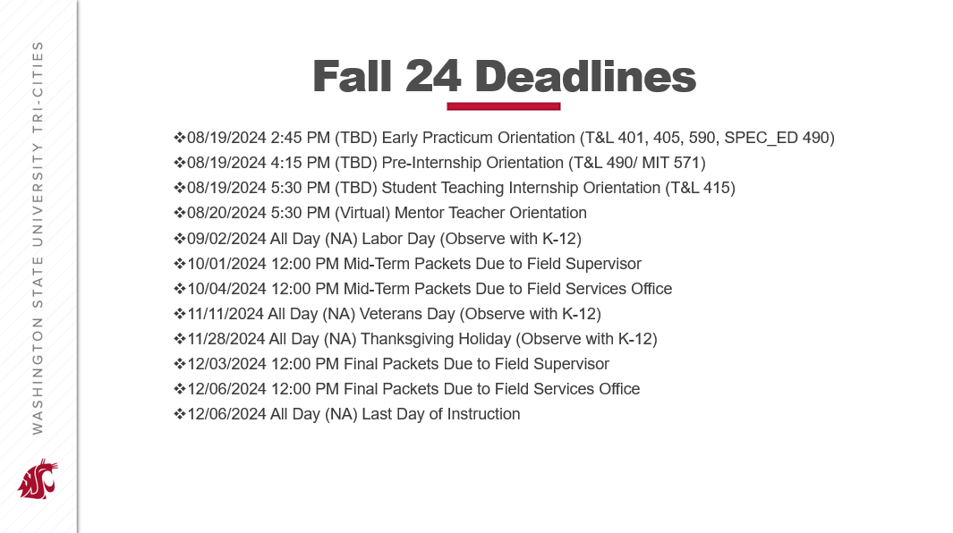

Appendix B: Topics for Discussion
The teaching profession is sophisticated and often requires deep conversations by teacher candidates with experienced mentors to better understand becoming an effective teacher. This document intends to provide ideas about what these topics could entail.
Connecting the current practicum with these topics is essential.
Early Practica
- TCH_LRN 401: Bilingual Education/English Language Learners
- TCH_LRN 402: Literacy & General Orientation
- TCH_LRN 405: Math and Science
- TCH_LRN 590: MIT general early practicum
- SPEC_ED 490: Special Education
Pre-Internship (TCH_LRN 490; MIT 571; TCH_LRN 469)
- Pre-internships allow the teacher candidate-controlled opportunities to integrate all aspects of teaching.
Student Teaching Internship (TCH_LRN 415; MIT 575)
- Student Teaching Internships allow the teacher candidate increasing responsibility to take over large portions of the teaching day.
- Use of the co-teaching model.

Recommended Topics
Planning | Instruction
- Lesson planning  - Professional Learning Communities (PLCs)/Teams  - Using standards  - Creating learning targets  - Using persona connections within lessons  - Connecting community and cultural assets to learning  - Vocabulary and symbols related to lesson content  - Curriculum  - Supplementing appropriateness  - Pacing charts  - Incorporating technology  - Using manipulatives and representations in instruction.  - Connecting students to their learning  - Wait time  - Remediation, extension of learning  - Classroom management supporting instruction  - Whole group vs. small group  - Differentiation  Assessment  - How to use formative assessment  - Summative assessments  - How to design an assessment  - Using standardized assessments  - Assessment administration  - Exit slips  - Informal vs. formal assessments  Classroom Management  - Setting expectations  - Reinforcing expectations  - Organizing the classroom  - Managing resources  - Monitoring behaviors  - Logistics of the classroom (attendance, lunch count)  - Pacing and time management  - Record keeping and documentation  - Classroom design/setup  - Transitions  - Technology  - Classroom signals and cueing (verbal/nonverbal)  - Proximity | - Instructional Rigor  - Questioning techniques  - Lesson pacing  - Lesson introductions  - Checking for understanding  - Using formative assessment  - Content application and adjustment  - Adjusting your lesson  - Using GLAD/AVID strategies  - Cooperative learning groups  - Classroom logistics that help instruction  - Entry Tasks  - Use of positive and negative reinforcement  Communication & Engagement  - Parent communications  - Student communications  - Administration communications  - Conferencing  - Community engagement  Inclusion & Equity  - Individual Education Plan (IEP) applications to the classroom  - How to work with the Special Education team  - The IEP processes  - 504 plan applications to the classroom.  - Monitoring students  - How to deal with CPS concerns  - Since Time Immemorial (STI) application to the classroom  - Viewing student backgrounds as an asset  - How to incorporate diversity within the classroom

Appendix C: Instructional Frameworks
Washington State uses the Danielson, Marzano, and CEL5D+ frameworks for teacher development and evaluation based on the school districts' negotiated agreement. Use your school district's instructional framework language when working with your mentor teacher and field supervisor.

School District List
You can ask your mentor teacher or look up the school district on the state listing for the correct framework:
https://ospi.k12.wa.us/sites/default/files/2023-10/district-framework-selections.xlsx

Danielson

https://ospi.k12.wa.us/educator-support/teacherprincipal-evaluation-program/frameworks-and-rubrics/charlotte-danielsons-framework-teaching

Marzano

https://ospi.k12.wa.us/educator-support/teacherprincipal-evaluation-program/frameworks-and-rubrics/marzanos-teacher-evaluation-model

CEL5D+
https://ospi.k12.wa.us/educator-support/teacherprincipal-evaluation-program/frameworks-and-rubrics/cel-5d-teacher-evaluation-rubric

Appendix D: Observation Tools
Reminder: the enclosed templates are not required but a resource for mentor teachers and field supervisors to use.
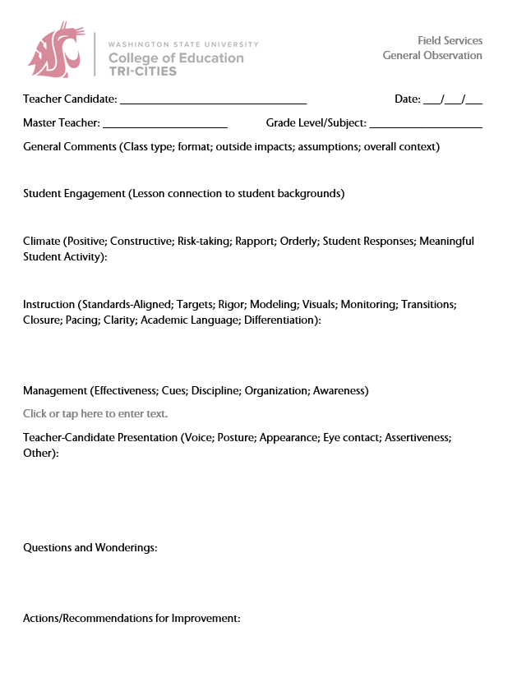
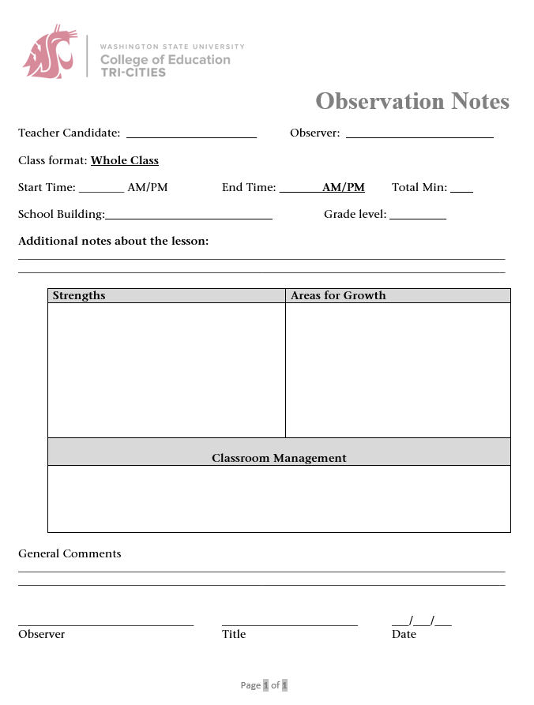
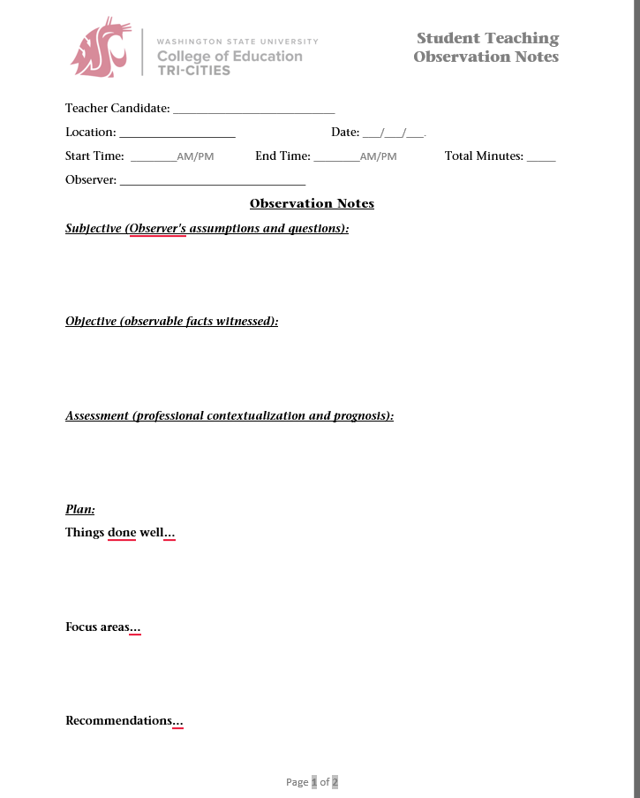
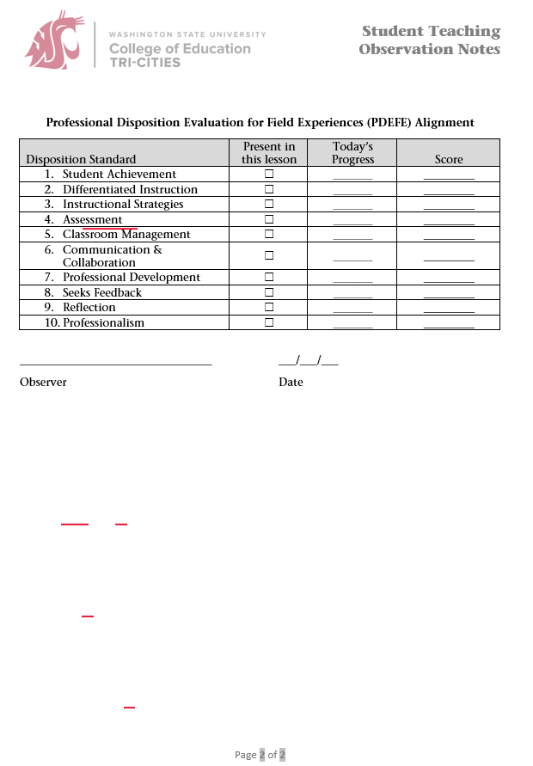

Appendix E: Pre-Internship Professional Dispositions Evaluation for Field Experiences (PI-PDEFE)
Please note that there are separate forms for the Mid-term and Final. Find the full editable forms online at:
Mid-term: https://tricities.wsu.edu/documents/2023/01/20-pdefe-midterm.docx/
Final: https://tricities.wsu.edu/documents/2023/01/19-pdefe-final.docx/

Appendix F: WSU Field Services

WSU Tri-Cities
Dr. John Mancinelli WSU Tri-Cities Field Services Director
O: 509-372-7237 email: John.mancinelli@wsu.edu
Ms. Catherine Denham WSU Tri-Cities Field Services Coordinator
O: 509-372-7135 email: catherine.denham@wsu.edu
Dr. Judy Morrison Academic Director
O: 509-372-7176 email: jamorrison@wsu.edu
Dr. Lindsay Lightner Alternative Route Academic Coordinator
O: 509-372-7366 email: llightner@wsu.edu
Mr. Chris Gana Traditional/MIT Academic Coordinator
O: 509-742-7474 email: cgana@wsu.edu

WSU Pullman
All mail for the Office of Field Services and Certification should be addressed to:
PO BOX 642114 Pullman, WA 99164-2114. Our Fax number is 509-335-2097
Emily Deen Field Services Director
O: 509-335-xxxx email: emily.deen@wsu.edu
Staci Bickelhaupt Certification Coordinator
O: 509-335-8146 email: sbickel@wsu.edu
Heidi Ritter Program Specialist, Field Services
School contracts, Vouchers, Clock Hours, Travel Reimbursements
O: 509-335-0925 email: hritter@wsu.edu
Tricia Benton Program Coordinator, Field Services
O: 509-335-8147 email: tricia.benton@wsu.edu
Guy Pitzer Places and Supervises Student Teachers & MITs in Pullman Area
O: 509-335-4095 email: gapitzer@inlandnet.com
Lori White Pullman Elementary Practicums
O: 509-335-7984 email: whitel@wsu.edu
Francene Watson Pullman Secondary Program
O: 509-335-5015 email: fwatson@wsu.edu

Jim Johnson Pullman Secondary Program and Supervises Student Teachers in Pullman Area
O: 509-432-9336 email: jrjohnson@wsu.edu
Kris Nilsson Fiscal Specialist, Dept. of Teaching and Learning (PO Box 642132)
supervisor Appointments and Payroll
O: 509-335-5027 email: knilsson@wsu.edu

College of Education Leadership
Karen Thomas-Brown Dean, College of Education
O: 509-335-4853 email: karen.thomasbrown@wsu.edu
Phyllis Erdman Associate Dean for Academic Affairs, College of Education
O: 509-335-4853 email: perdman@wsu.edu
Tariq Akmal Chair, Department of Teaching &Learning
O: 509-335-7296 email: takmal@wsu.edu
Angie Hammond Director, Office of Undergraduate Education
O: 509-335-4855 email: angiehammond@wsu.edu

