

Early Practicum
(TCH_LRN 401, 402, 405, 590, SPEC_ED 490)
Mentor Teacher Handbook
Field Experiences Office

Department of Teaching and Learning
Updated: Fall 2024


The College of Education contributes to the theory and practice of the broad field of education and dedicates itself to understanding and respecting learners in diverse cultural contexts. We facilitate engaged learning and ethical leadership in schools and clinical settings. We seek collaboration with diverse constituencies, recognizing our local and global responsibilities to communities, environments, and future generations.

Dr. John Mancinelli
Field Services Director
WSU Tri-Cities Office of Field Services
WSU Tri-Cities

O: 509-372-7237
E: John.mancinelli@wsu.edu
tricities.fieldservices@wsu.edu

Table of Contents
Welcome! 5
WSU Tri-Cities Field Services Team 5
Mentor Teacher Qualifications and Competencies 6
Role of the Mentor Teacher 6
Creating Teacher Candidate Confidence 6
Modeling Professional Skills and Behaviors 6
Supervision of the Teacher Candidate 7
Appropriate Release of Responsibility to the Teacher Candidate 7
Communications with Teacher Candidates 8
Use Clear and Actionable Feedback 8
Create Routine 9
Communications with the Field Supervisor 9
Teacher Candidate Development 9
Evaluation Collaboration 10
At-Risk Teacher candidates 10
Direct Communication with the Teacher Candidate and Field Supervisor about Concerns. 10
Teacher Candidate plan of improvement. 10
Ethical Concerns 11
The Program Coordinator 11
The Field Supervisor 12
The Seminar Faculty 12
The Early Practicum 13
Teacher Candidate Minimum Contact Time 13
Learning Walk Teacher Candidate Activities at Learning Walk Lab School 13
Learning Walk Format 13
Mentor Tasks at Learning Walk Lab Schools 14
Suggested Timeline 14
Evaluation for Learning Walk Practicum Students 15
Teacher Candidate Activities for TCH_LRN 401, 402, 590, and SPEC_ED 490 15
Mentor Tasks: 16
Suggested Timeline 17
Evaluation 19
Appendix A: Fall 2024 Deadline Schedule 19
Appendix B: Topics for Discussion 21
Recommended Topics 21
Appendix C: Instructional Frameworks 23
School District List 23
Danielson 23
Marzano 23
CEL5D+ 23
Appendix D: Sample Investigation for TCH_LRN 402 24
Appendix E: Observation Tools for TCH_LRN 401, 405, 590, and SPEC_ED 490 25
Appendix F: Learning Walk Early Practicum Performance Criteria Journal (EPPCJ) 30
Appendix G: Early Practicum Performance Criteria Journal (EPPCJ) for TCH_LRN 401, 405, SPEC_ED 490 31
Appendix H: WSU Field Services 37
WSU Tri-Cities 37
WSU Pullman 37
College of Education Leadership 38


Welcome!
Dr. John Mancinelli
WSU Tri-Cities Field Services Director
John.mancinelli@wsu.edu
We are proud to have you as part of the WSU College of Education team dedicated to training and developing the next generation of highly effective educators.
Mentor teachers are critical for teacher candidates' journey where their academic career now must translate to real-world situations. As a mentor teacher, you will encourage, coach, model, and evaluate teacher candidates as part of a field supervisor and faculty team. Please use this handbook and refer to it often during your mentorship. Also, know that our team is here to help you successfully mentor.

WSU Tri-Cities Field Services Team
 |  |  | 
Dr. Judy Morrison  Academic Director  509-372-7176  jamorrison@wsu.edu | Dr. Lindsay Lightner  Alternate Route  Academic Coordinator  509-372-7366  llightner@wsu.edu | Mr. Chris Gana  Traditional/MIT Academic Coordinator  509-742-7474  cgana@wsu.edu | Ms. Catherine Denham  Field Services  Coordinator  509-372-7135  Catherine.denham@wsu.edu

Mentor Teacher Qualifications and Competencies
Individuals serving as a mentor teacher must possess the following qualifications:
- Successful teaching for at least three years.
- Washington State Certified.
- Demonstrate effective instruction, classroom management, assessment, communication, and teamwork as determined by the school district.
- Be willing to work with a teacher candidate and complete paperwork and evaluations.
- Be willing to model effective professional behaviors and practices for a teacher candidate.

Role of the Mentor Teacher
The mentor teacher is an outstanding educator who helps a university teacher candidate develop confidence and the skills necessary to begin a teaching career. The mentor teacher models, guides, challenges, and professionally critiques the teacher candidates' characteristics, behaviors, knowledge, and skills to prepare them for the professional world.

Creating Teacher Candidate Confidence
The mentor should make the teacher candidate feel welcomed and a part of their classroom and school community. Many teacher candidates in their early practicum may be quiet and need encouragement to self-advocate and present themselves publicly to students, parents, peers, and administration. To help acclimate the teacher candidate to your school, the mentor should plan opportunities for the teacher candidate to observe, practice, pilot, receive feedback, make corrections, and perform on the classroom stage. Teacher candidate confidence increases when the mentor teacher models and coaches instructional strategies ahead of the teacher candidate's turn to 'take the stage.' Rehearsing actions helps the teacher candidate understand the mentor's decision-making process and prepare for the task.

Modeling Professional Skills and Behaviors
Modeling good professional behaviors for teacher candidates is essential. Teacher candidates need to learn how to face challenges in teaching with a professional perspective. Mentors should hold conversations with teacher candidates at appropriate times before, during, and after they model a particular skill, action, or event to take advantage of learning opportunities. Conversations help the teacher candidate to understand the rationale behind the mentor's actions and decision-making. In turn, the goal is for the teacher candidate to begin to make sound decisions autonomously.
A mentor should not worry about making mistakes. Everyone makes mistakes! As a mentor, acknowledge your mistakes and press the 'redo' button as often as needed. The important thing is that the teacher candidate sees how the mentor teacher adjusts and adapts to any situation – including making mistakes.
Here are some examples of things mentors can model:
- Decision-making about classroom management, curriculum, and instruction.
- Instruction in action with the use of formative assessment.
- Building relationships with peers, administration, students, parents, and the community.
- Use of professional language, terms, and processes.
- Lesson planning.
- Formative and summative assessment: how to design, implement, and use.
- How to have crucial conversations, in a professional manner, with students, peers, administrators, and parents.
- Managing student off-task or disruptive behavior.

Supervision of the Teacher Candidate
A Washington Certified teacher must always supervise teacher candidates. An early practicum teacher candidate cannot substitute for their mentor teacher. They can, however, continue their field experience in your classroom with a certified substitute in the room. They can also visit a colleague's classroom to assist and observe in your absence.

Appropriate Release of Responsibility to the Teacher Candidate
Just as an athletic coach guides players during a game, a mentor teacher will eventually be on the sidelines providing real-time feedback to the teacher candidate. Below are suggestions to make this experience positive and constructive for all involved.
- Explain to the class that a mentor's job is to coach the teacher candidate and may provide input to them in the process. Depending on the age level of the students, this will help normalize the interactions and increase K-12 students' respect for the teacher candidate.
- Set the teacher candidate up for success to appear confident in front of students. Mentally rehearse the activity with the teacher candidate before they perform it. Try to limit corrections to the teacher candidate in front of the students as much as possible.
- Take time to reflect with the teacher candidate. When the teacher candidate completes an activity, allow them time to process and reflect on what occurred. Sometimes there is time to debrief with the teacher candidate while students engage in independent work. Alternatively, the mentor can arrange a time before, during prep, lunch, or after school to talk about the activity. As mentors, we want you to foster reflective practice with teacher candidates continually. Here are some common questions to consider in conversations with a teacher candidate:
  - What do you think went well and why?
  - What needs more focus and refinement from your perspective?
  - What was the level of student engagement during the activity, and how did you know?
  - What did you think about….?
  - How could greater student engagement occur in your next lesson?
  - How many students understood the activity, and how do you know?
After reflecting with the teacher candidate, the mentor teacher can provide examples or model effective ways to improve. Actionable steps are essential to the growth of the teacher candidate!

Early practicum teacher candidates usually have limited responsibility because they are new to the program. Depending on how many pedagogical and content classes the teacher candidate has under their belt will determine how much release the mentor teacher allows. Work with the field supervisor to determine the teacher candidate's appropriate level of responsibility.

Communications with Teacher Candidates
Good communication is key to the success of teacher candidates. We encourage mentors to communicate soon, frequently, and directly. Time is of the essence, and teacher candidates are young professionals needing to demonstrate competency in many skills. Being polite yet direct is necessary for the mentor teacher so that the teacher candidate can make the appropriate improvements quickly. Teacher candidates are taught to seek and receive pithy feedback and immediately improve in response.
As a mentor, give explicit constructive feedback when you see concerns or needed improvements! Set up regular meetings to discuss accomplishments and plan for the following week's activities.

Use Clear and Actionable Feedback
Ultimately, teacher candidates have limited time to demonstrate skills and knowledge. Therefore, the mentor teacher must communicate feedback directly and frequently. Withholding the critique of the teacher candidate to protect their feelings only hurts them in the long run. We encourage mentors to:
- Use specific examples.
Mentor, "The lesson introduction was well organized. The topic focus was appropriate, and you connected previous learning for the students."
- Include a growth statement.
Mentor, "Now, you need to work on lesson planning. You need to design a formative assessment after the first new concept is introduced to determine the differentiation needed in the next phase of your lesson."
- Include a goal timeline.
Mentor, "Be ready to….by…."
- Point out significant concerns.
Mentor, "I am concerned about…."

Create Routine
- Establish a daily/weekly routine for consultation, collaboration, and team planning.
- Assist the teacher candidate in developing their continuous improvement process.

Communications with the Field Supervisor
Field supervisors typically have a caseload of fifteen to twenty teacher candidates. Because they coordinate with so many schedules, their time is limited. Please coordinate observations and visitations with the field supervisor on their schedule balanced with your limitations. Field supervisors can drop in unannounced as well.
The field supervisor regularly contacts you, the mentor, and the teacher candidate. The field supervisor's observations don't necessarily require the mentor's availability unless previously arranged. For instance, the field supervisor may observe the teacher candidate and arrange to connect with the mentor teacher for a few minutes after they meet as the teacher candidate leads the class. The field supervisor may also follow up with the mentor teacher after the observation through email, a phone call, or zoom meeting.
The field supervisor will reach out on occasion to check in with you; however, do not hesitate to reach out to the field supervisor with questions at any point.

Teacher Candidate Development
Knowing if the teacher candidate matures appropriately is tricky for the mentor teacher to figure out. We encourage you to work with the field supervisor to determine the appropriate pacing of the field experience. Field supervisors have good perspectives of typical teacher candidate maturation and pacing. They also understand the WSU College of Education's expectations and standards for teacher candidate performance. Ask for their perspectives and use them as a sounding board before crucial conversations with the teacher candidate.
This handbook contains a suggested timeline that mentor teachers can use to determine appropriate readiness by the teacher candidate to take on more responsibility.

Evaluation Collaboration
The mentor and field supervisor evaluate the teacher candidate's performance. The mentor and field supervisor can often have quick conversations before or after observations, or they may schedule a time to talk or conduct a conversation via email or zoom. Ultimately, the mid-term and final evaluations reflect the collaboration between the mentor and the field supervisor.

At-Risk Teacher candidates
In most cases, there are minor issues that a teacher candidate needs to address. These instances are usually quickly improved. There are cases, however, where a teacher candidate significantly struggles or demonstrates large deficits during their field experiences. On occasion, some teacher candidates do not respond to corrections. The mentor teacher will inform the field supervisor and work with the teacher candidate to rectify these deficits quickly.

Direct Communication with the Teacher Candidate and Field Supervisor about Concerns.
As soon as a pattern (3 or more occurrences) of poor performance is observed by either the mentor teacher or field supervisor, the teacher candidate must receive immediate feedback in both verbal and written formats.
Steps:
- Hold a conversation with the teacher candidate where specific critical feedback is shared with specificity and recommendations to fix the issue.
- Provide a due date for the improved behaviors or skills to be demonstrated by the teacher candidate.
- Email a meeting summary to the teacher candidate and field supervisor outlining the conference, concerns, recommendations, and timeline for improvement.

Teacher Candidate plan of improvement.
The field supervisor may implement a formal CoEd Student Improvement Plan. The field supervisor and mentor teacher will collaborate to outline the specific issues. The plan will outline concrete steps for the teacher candidate to follow and explain the level of performance expected by assigned deadlines.
Field supervisor steps:
- Develop the student improvement plan with the mentor teacher.
- Meet with the teacher candidate and mentor teacher to discuss and clarify the Student Improvement Plan.
- The field supervisor, teacher candidate, and mentor teacher sign the Student Improvement Plan.
- Email the signed Student Improvement Plan to the Field Services Director (john.mancinelli@wsu.edu)

Ethical Concerns
In the event a teacher candidate demonstrates anything illegal, immoral, or unethical, the mentor teacher needs to:
- Immediately notify the supervising principal and the field supervisor.
- The WSU Tri-Cities Field Service Office and School District or Authorities will remove the teacher candidate while investigating.
After investigating the concerns, the University Field Service Office will adjudicate the case and administer consequences, if appropriate. Legal actions may also occur, depending on the substantiated circumstances. If concerns are not substantiated, the teacher candidate may return to their practicum or have an alternate placement to complete the practicum as determined by WSU Field Services Office.

The Program Coordinator
The field services coordinator is available when you are in need of information or need to communicate concerns. Please feel free to reach out to our field services coordinator:
- Catherine Denham
O: 509-372-7135 E: Catherine.denham@wsu.edu
Each teacher preparation program has a coordinator that works closely with students to help facilitate the successful completion of graduation and certification requirements. If your teacher candidate has programmatic questions, please feel free to direct them to contact:
- Alternate Route Program, Dr. Lindsay Lightner
O: 509-372-7366 E: llightner@wsu.edu
- Undergraduate or MIT Programs, Mr. Chris Gana
O: 509-742-7474 E: cgana@wsu.edu

The Field Supervisor
The University field supervisor represents the university program. The field supervisor is an instructor, advisor, coach, and evaluator for the teacher candidate and a resource and support person for the mentor teacher.
The field supervisor is in close contact with building personnel, the district coordinator, the WSU Tri-Cities Field Services Director, and the WSU Pullman Office of Field Services and Certification. Field supervisors are frequently called upon to clarify the university program, eliminate misunderstandings, or resolve conflicts between the mentor teacher, School District, and the teacher candidate. Most field supervisors possess years of teaching, and many also have years of administration experience. This experience is a valuable resource for the entire team. The field supervisor is evaluated and reports to the Field Services Director. The field supervisor has the authority to work with the school district, principal, and mentor teacher to adapt the field experience to meet the needs of all parties.

The Seminar Faculty
Concurrent with the field experience, teacher candidates take a seminar course focusing on the field experience. In a seminar, teacher candidates share experiences and problem-solve issues they face. Additionally, they receive training on pedagogical strategies and high-value educational practices. As a mentor teacher, feel free to reach out to any of the faculty with questions.
- TCH_LRN 401 - Bilingual/English Language Learners (6 hrs/wk, 90 hrs total)
  - Dr. Eric Johnson (e.johnson@wsu.edu) 509-372-7304
- TCH_LRN 402 - Instructional Strategies, Literacy, Technology, and Assessment (3 hrs/wk, 45 hrs total)
  - Dr. John Mancinelli (john.mancinelli@wsu.edu) 509-372-7237
- TCH_LRN 405 - Math and Science (3 hrs/wk, 45 hrs total)
  - Dr. Judy Morrison (jamorrison@wsu.edu) 509-372-7176
- TCH_LRN 590 - MIT content experience (16 hrs/wk, 210 hrs total)
  - Dr. John Mancinelli (john.mancinelli@wsu.edu) 509-372-7237
- SPEC_ED 490 - Special Education (6 hrs/wk, 90 hrs total)
  - Yun-Ju Hsiao (yhsiao@wsu.edu) 509-372-7505
- TCH_LRN 490/MIT 571 – Pre-Internship (16 hrs/wk, 210 hrs total)
  - Dr. Lindsay Lightner (llightner@wsu.edu) 509-372-7366
- TCH_LRN 415/MIT 575 – Student Teaching Internship (40 hrs/wk, ~600 hrs total)
  - Dr. John Mancinelli (john.mancinelli@wsu.edu) 509-372-7237

The Early Practicum
There are three WSU teacher preparation field experience categories: Early Practicums, Pre-Internships, and Student Teaching Internships.
The Early Practicums are field experiences a teacher candidate has when starting the Teaching and Learning program. These teacher candidates joined the program with few or no pedagogy or content courses. These practicums acquaint teacher candidates with the public-school environment and, more specifically, content-specific (English Language Learners, Bilingual Learner Education, math, literacy, science, Special Education, etc.) curriculum applicable to the classroom. The focus and emphasis for these experiences are to expose teacher candidates to content standards, design, instruction, and assessment in practice. This year, we have two types of early practicums: the Learning Walk format at Learning Walk Lab schools for TCH_LRN 402 teacher candidates, and the traditional early practicum format for TCH_LRN 401, 405, 590, and SPEC_490.

Teacher Candidate Minimum Contact Time
Course | Minimum Requirements
T&L 401 | 6 hrs/wk, 90 hrs total
T&L 402 | 3 hrs/wk, 45 hrs total
T&L 405 | 3 hrs/wk, 45 hrs total
SPEC_ED 490 | 6 hrs/wk, 90 hrs total
T&L 590 | 6 hrs/wk, 90 hrs total

Learning Walk Teacher Candidate Activities at Learning Walk Lab School
Our T&L 402 students will be completing their early practicum in the Learning Walk format this year. In this format, students are assigned to a school placement and, with their field supervisor, observe a set of classrooms at their school placement for a set number of weeks and then volunteer in classrooms for a set number of weeks. These school placements are designated WSU Tri-Cities College of Education Laboratory Schools. For more information, please look at the Learning Walk Mentor Teacher Handbook.

Learning Walk Format
Weeks 1, 2, 3, 4 | Weeks 5, 6, 7 | Weeks 8, 9, 10 | Weeks 11, 12, 13, 14
Observation Format  - 45 min Topic Lesson & Framework  - 30 min Observation  - 15 min Debrief  - 30 min Observation  - 15 min Debrief and Recap | Classroom Volunteer Format  - 15 min Mentor & Candidate conversation  - 2.75 hrs Support and work with students  - 15 min Reflection & Mentor Feedback | Observation Format  - 45 min Topic Lesson & Framework  - 30 min Observation  - 15 min Debrief  - 30 min Observation  15 min Debrief and Recap | Classroom Volunteer Format  - 15 min Mentor & Candidate conversation  - 2.75 hrs Support and work with students  15 min Reflection & Mentor Feedback

Mentor Tasks at Learning Walk Lab Schools
Practicum Level | Mentor Teacher Tasks
Early Practicum  (T&L 402) | - Invite school field supervisor and teacher candidates to observe  - Coordinate with teacher candidate(s) for volunteer weeks  - Give real-time feedback to teacher candidate(s)

In the learning walk format, the role of the mentor teacher is to create an atmosphere in their classroom that is conducive to observation. Mentor teachers in this format are also encouraged to give real-time feedback to teacher candidates who volunteer in their classroom. The goal of the learning walk format is to give teacher candidates the opportunity to observe effective instruction and to learn the basics of instruction through their observations.

Suggested Timeline
Week | Teacher candidate | Field supervisor/ mentor teacher
1 – 4 | - Meet with the field supervisor for introductions.  - Attend observations and fill out investigations in investigations booklet.  - Attend seminar class. | - Field supervisor will lead observation groups and discussions.  - Field supervisor will initial weekly log time.
5 – 7 | - Assists with small tasks assigned by the mentor and seminar faculty. | - The mentor teacher observes the teacher candidate and provides feedback.  - The mentor teacher will initial weekly log time.
8 | - Completes EPPCJ narrative entries in sections 1 through 6.  - Submit the completed EPPCJ to the field supervisor for review. | - The field supervisor discusses any areas of concern, enters short feedback and scores on form.
9 – 10 | - Attend observations and fill out investigations in investigations booklet.  - Attend seminar class. | - Field supervisor will lead observation groups and discussions.  - Field supervisor will initial weekly log time.
11 – 13 | - Assists with small tasks assigned by the mentor and seminar faculty. | - The mentor teacher observes the teacher candidate and provides feedback.  - The mentor teacher will initial weekly log time.
14 | - Completes EPPCJ narrative entries in sections 1 through 6.  - Submit the completed EPPCJ to the field supervisor for review.  - Submit log sheet to field supervisor.  - Submit 3 investigations to field supervisor (must be in PDF format). | - The mentor teacher and field supervisor meets with the Teacher candidate to discuss the EPPCJ review and scores with recommendations for actionable improvements.

Evaluation for Learning Walk Practicum Students
The "Early Practicum Performance Criteria & Journal" (EPPCJ) (see Appendix E) is the evaluation tool for all early field experiences. The criteria come from the Professional Dispositions Evaluation of Field Experiences (PDEFE) and are modified for early practicum students to achieve.
- The Teacher candidate will complete sections 1 through 6 by entering their reflections in the journal during the semester.
- One week before mid-term and finals, the Teacher candidate will deliver the journal to d the field supervisor to complete sections 7 through 10.
- The field supervisor will write the narrative in areas 7 through 10 and score those (7 through 10).
- The field supervisor meet with the Teacher candidate for Mid-term and Finals to review the EPPCJ feedback.
- The Teacher candidate will collect the signed EPPCJ and log sheet after the mid-term or final conferences, convert the document into a PDF® and submit it to the field supervisor attached to an email.
- The field supervisor will submit the mid-term or final version of the EPPCJ to the WSU Tri-Cities Field Services Office via email (tricities.fieldservices@wsu.edu).
- The Field Services Office, upon receipt of the EPPCJ and Log sheet, will issue the grade for the field experience.

Teacher Candidate Activities for TCH_LRN 401, 402, 590, and SPEC_ED 490
The teacher candidate's activities depend on the practicum they are taking. For instance, TCH_LRN 405 focuses on practicing learning strategies and instruction for math and science. In TCH_LRN 405 a teacher candidate will complete assignments about math/ science in the classroom during their field experience. The teacher candidate must communicate these assignments to their mentor and field supervisor. Teacher candidates must work with the mentor teacher to adapt the project to the classroom context.
Additionally, teacher candidates are to engage in activities outlined by the "Early Practicum Performance Criteria & Journal" (EPPCJ). These activities align with the national teaching standards.

Mentor Tasks:
Practicum Level | Mentor Tasks
Early Practicum  (T&L 401, 405, 590, SPEC_ED 490) | - 2 written observations  - Weekly log sheet signoff  - Mid-term EPPCJ Evaluation  - Final EPPCJ Evaluation
- Approve weekly log sheet – Each week, the teacher candidate is expected to review their schedule with the mentor to coordinate activities. Mentor teachers are asked to initial each week's approval at least one week in advance.
- Observations– a minimum of 2 written observations
Mentors make several observations of the Teacher candidate during an early practicum. Most feedback is offered verbally; however, the college program requires a minimum of two observations with written feedback.

Written feedback can be done by hand on a notepad or typed in a Word® document. Example observation forms are located in Appendix D.
Maximizing the observation feedback is essential to the development of the Teacher candidate. We recommend that you determine the focus of the observation before it occurs and provide the observation's emphasis to the teacher candidate beforehand. The focus can vary from a whole-class general observation where the mentor captures the entire context or as particular as just looking for student engagement. The focus can be any aspect of preparation, instruction, engagement, assessment, safety, etc.

Some typical early practicum focus topics can be:
- Teacher voice – is it appropriate for the size of the group. Do they portray confidence?
- Behavior management basics – how to set expectations, reinforce expectations; how to administer minor corrections. Remember that most early practicum students have not had their classroom management course yet!
- Lesson topic introduction – how are they presenting the topic? Are they connecting the topic to previous or future learning for the student? Are they making personal connections for students to relate to the topic? Are they accurate in topic information?
- A content concept, skill or knowledge.
- Mid-term and Final Evaluation: The mentor teacher is responsible for input and collaboration with the field supervisor to score each of the ten dispositions on the Early Practicum Performance Criteria Journal (EPPCJ). Also, the mentor teacher will collaborate with the field supervisor to provide narrative feedback in dispositions 7 through 10. The teacher candidate must provide the EPPCJ to the mentor teacher and field supervisor one week before mid-term and finals with a completed narrative in sections 1 through 6.
- Final Packet: The teacher candidate is responsible for managing all paperwork included in the final packet. The mentor teacher is responsible for reviewing and approving the documentation, including:
  - Log sheet: The mentor initials approval of documented hours.
  - 2 mentor teacher Observations. The mentor takes notes while observing and provides actionable feedback to the teacher candidate.
  - Mid-term and Final Evaluation: Early Practicum Performance Criteria Journal (EPPCJ). The mentor teacher provides feedback in sections 7 through 10 and scores all ten areas with the field supervisor.
- Exit Survey (Mentors are sent an email survey from WSU Pullman). We value and use your feedback to improve our teacher preparation program continuously. When distributed, we ask mentor teachers to complete the survey as soon as possible.

Suggested Timeline
Week | Teacher candidate | mentor teacher
1 | - Meet with the mentor for introductions.  - Become acquainted with building and classroom expectations.  - Attend seminar class. | - The mentor teacher and field supervisor meet with the Teacher candidate to review practicum expectations, resources, timelines, and deliverables. The Teacher candidate must provide the field supervisor with a weekly teaching schedule to arrange observation dates and times.
2 - 6 | - Observe mentor teacher instruction, planning, assessment, reflection, and interactions with students, parents, peers, and administration.  - Assists with small tasks assigned by the mentor and seminar faculty. | - The mentor teacher observes the teacher candidate and provides a minimum of one written feedback.  - The mentor teacher reviews and approves the teacher candidate's weekly log sheet.
7 | - Completes EPPCJ narrative entries in sections 1 through 6.  - Submit the completed EPPCJ to the field supervisor and mentor teacher for review. | - The field supervisor and mentor teacher discuss any areas of concern and agree on scores for all 10 areas. The field supervisor enters short feedback and scores on form.
8 | - Meet with the mentor teacher and field supervisor to receive feedback on EPPCJ and recommendations for improvement. | - The mentor teacher and field supervisor meet with the Teacher candidate to discuss the EPPCJ review and scores with recommendations for actionable improvements.
9 – 14 | - Assists with small tasks assigned by the mentor and seminar faculty. | - Observe the Teacher candidate and provide a minimum of one written feedback.  - Review and approve teacher candidate's weekly log sheet.
15 | - Schedule the final meeting with the mentor teacher and Field supervisor.  - Complete the final EPPCJ sections 1 – 6.  - Deliver the EPPCJ to the mentor teacher and field supervisor one week before the final meeting. | - Review the EPPCJ. The mentor teacher provides input to the field supervisor in all areas and scores all areas.
16 | - Meet with the mentor teacher and field supervisor for the final evaluation and collect signatures on all documents.  - After the final evaluation, collect all documents and convert them to PDFs.  - Submit the final packet to the field supervisor by the deadline. | - The mentor teacher and field supervisor provide verbal feedback on the final EPPCJ narrative and scores.  - The mentor teacher, field supervisor, and teacher candidate sign the required documentation (verifying communication)

Evaluation
The "Early Practicum Performance Criteria & Journal" (EPPCJ) (see Appendix E) is the evaluation tool for all early field experiences. The criteria come from the Professional Dispositions Evaluation of Field Experiences (PDEFE) and are modified for early practicum students to achieve.
- The Teacher candidate will complete sections 1 through 6 by entering their reflections in the journal during the semester.
- One week before mid-term and finals, the Teacher candidate will deliver the journal to the mentor teacher and the field supervisor to complete sections 7 through 10.
- With input from the mentor teacher, the field supervisor will write the narrative in areas 7 through 10 and score all areas (1 through 10).
- The mentor teacher and field supervisor meet with the Teacher candidate for Mid-term and Finals to review the EPPCJ feedback.
- The Teacher candidate will collect the signed EPPCJ and log sheet after the mid-term or final conferences, convert the document into a PDF® and submit it to the field supervisor attached to an email.
- The field supervisor will submit the mid-term or final version of the EPPCJ to the WSU Tri-Cities Field Services Office via email (tricities.fieldservices@wsu.edu).
- The Field Services Office, upon receipt of the EPPCJ and Log sheet, will issue the grade for the field experience.

Appendix A: Spring 2025 Deadline Schedule
Deadlines are a courtesy to you as a mentor; however, the responsibility to meet these deadlines lies with the teacher candidate. They are responsible for prompting you for your assistance and completion of documentation. National holidays are observed by WSU teacher candidates on the K-12 calendar not the WSU Calendar.

Appendix B: Topics for Discussion
The teaching profession is sophisticated and often requires deep conversations by teacher candidates with experienced mentors to better understand becoming an effective teacher. This document intends to provide ideas about what these topics could entail.
Connecting the current practicum with these topics is essential.
Early Practica
- TCH_LRN 401: Bilingual Education/English Language Learners
- TCH_LRN 402: Literacy & General Orientation
- TCH_LRN 405: Math and Science
- TCH_LRN 590: MIT general early practicum
- SPEC_ED 490: Special Education
Pre-Internship (TCH_LRN 490; MIT 571; TCH_LRN 469)
- Pre-internships allow the teacher candidate controlled opportunities to integrate all aspects of teaching.
Student Teaching Internship (TCH_LRN 415; MIT 575)
- Student Teaching Internships allow the teacher candidate increasing responsibility to take over large portions of the teaching day.
- Use of the co-teaching model.

Recommended Topics

Planning
- Lesson Planning
- Professional Learning Communities/Teams
- Using Standards
- Creating learning targets
- Using persona connections within lessons.
- Connecting community and cultural assets to learning
- Vocabulary and symbols related to lesson content
- Curriculum
- Supplementing appropriateness
- Pacing charts
Instruction
- Instructional Rigor
- Questioning techniques
- Lesson pacing
- Lesson introductions
- Checking for understanding
- Using formative assessment
- Content application and adjustment
- Adjusting your lesson
- Using GLAD/AVID strategies
- Cooperative learning groups
- Classroom logistics that help instruction
- Entry Tasks
- Incorporating technology
- Using manipulatives and representations in instruction.
- Connecting students to their learning.
- Wait time.
- Remediation and extension of learning
- Classroom management supporting instruction
- Whole group vs. small group.
- Differentiation
Assessment
- How to use formative assessment.
- Summative assessments
- How to design an assessment
- Using standardized assessments
- Assessment administration
- Exit slips
- Informal vs. formal assessments
Classroom Management
- Setting Expectations
- Reinforcing Expectations
- Organizing the classroom.
- Managing resources
- Monitoring behaviors
- Logistics of the classroom (attendance, lunch count)
- Pacing and time management
- Record keeping and documentation
- Classroom design/setup
- Transitions
- Technology
- Classroom signals and cueing (verbal/nonverbal).
- Proximity
- Use of positive and negative reinforcement
Communication & Engagement
- Parent Communications
- Student communications
- Administration communications
- Conferencing
- Community Engagement
Inclusion & Equity
- Individual Education Plan (IEP) applications to the classroom.
- How to work with the Special Education team
- The IEP process
- 504 application to the classroom.
- Monitoring Students
- How to deal with CPS concerns.
- Since Time Immemorial (STI) application to the classroom
- Viewing student background as an asset
- How to incorporate diversity within the classroom

Appendix C: Instructional Frameworks
Washington State uses the Danielson, Marzano, and CEL5D+ frameworks for teacher development and evaluation based on the school districts' negotiated agreement. Use your school district's instructional framework language when working with your teacher candidate.

School District List
https://ospi.k12.wa.us/sites/default/files/2023-10/district-framework-selections.xlsx

Danielson
https://ospi.k12.wa.us/educator-support/teacherprincipal-evaluation-program/frameworks-and-rubrics/charlotte-danielsons-framework-teaching

Marzano
https://ospi.k12.wa.us/educator-support/teacherprincipal-evaluation-program/frameworks-and-rubrics/marzanos-teacher-evaluation-model

CEL5D+
https://ospi.k12.wa.us/educator-support/teacherprincipal-evaluation-program/frameworks-and-rubrics/cel-5d-teacher-evaluation-rubric

Appendix D: Sample Investigation for TCH_LRN 402

Appendix E: Observation Tools for TCH_LRN 401, 405, 590, and SPEC_ED 490
Reminder: the enclosed templates are not required but a resource for mentor teachers and field supervisors to use.
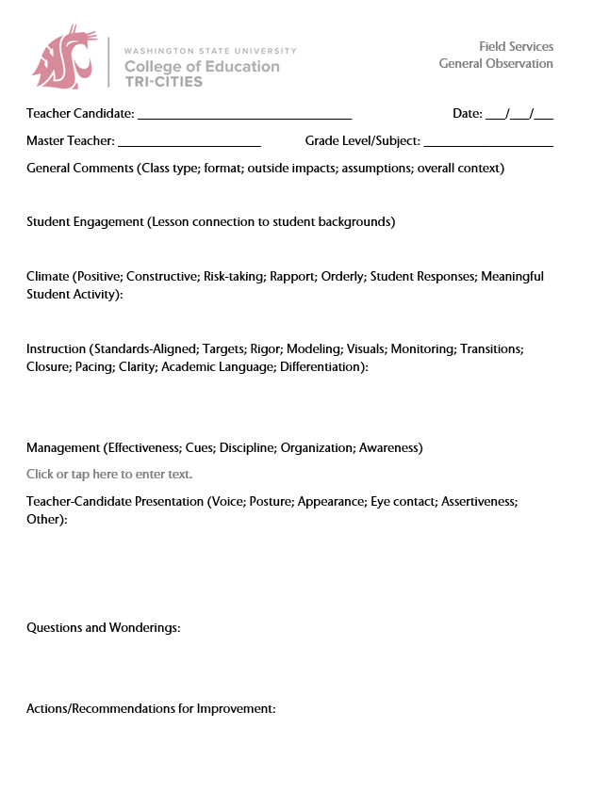
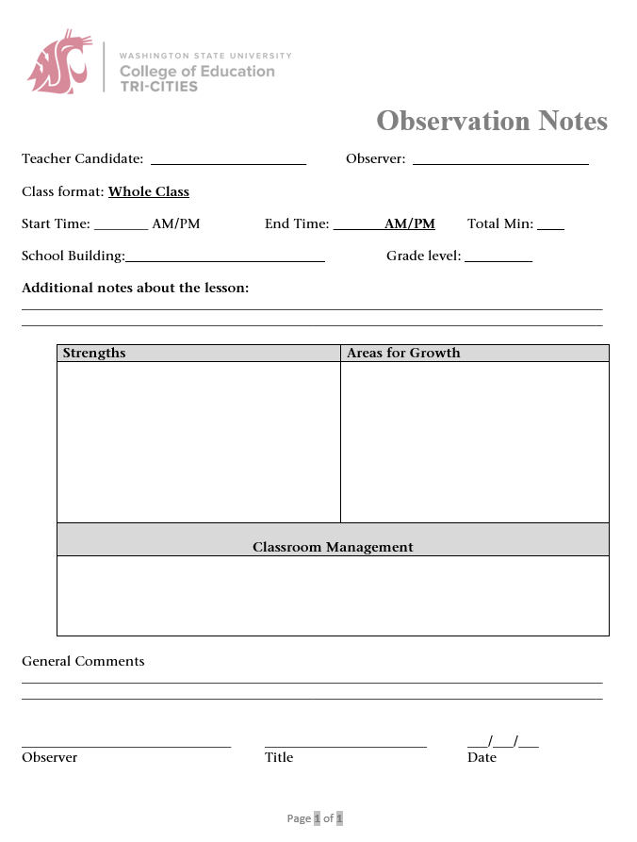

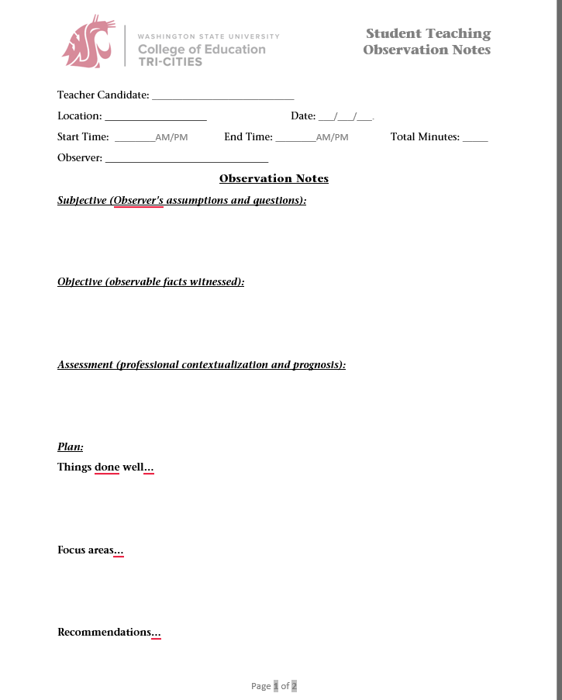

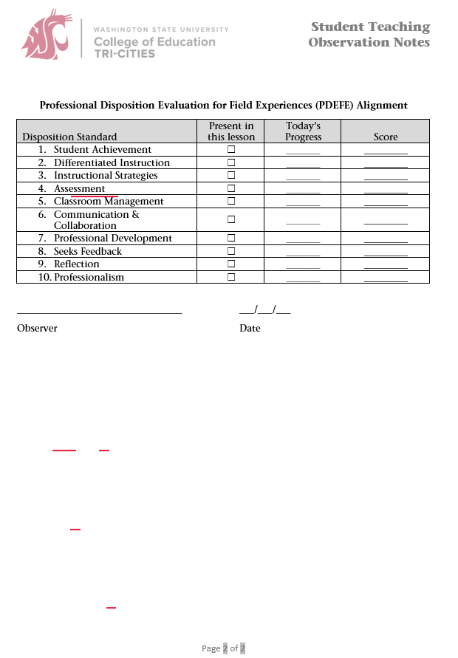

Appendix F: Learning Walk Early Practicum Performance Criteria Journal (EPPCJ)
Please note that there are separate forms for the Mid-term and Final. The attached version is the "final" used for the end-of-term.

Appendix G: Early Practicum Performance Criteria Journal (EPPCJ) for TCH_LRN 401, 405, SPEC_ED 490
Please note that there are separate forms for the Mid-term and Final.
Midterm: https://tricities.wsu.edu/documents/2023/01/early-practicum-performance-criteria-journal-eppcj.docx/
Final: https://tricities.wsu.edu/documents/2023/01/2023-early-practicum-performance-criteria-journal-eppcj.docx/

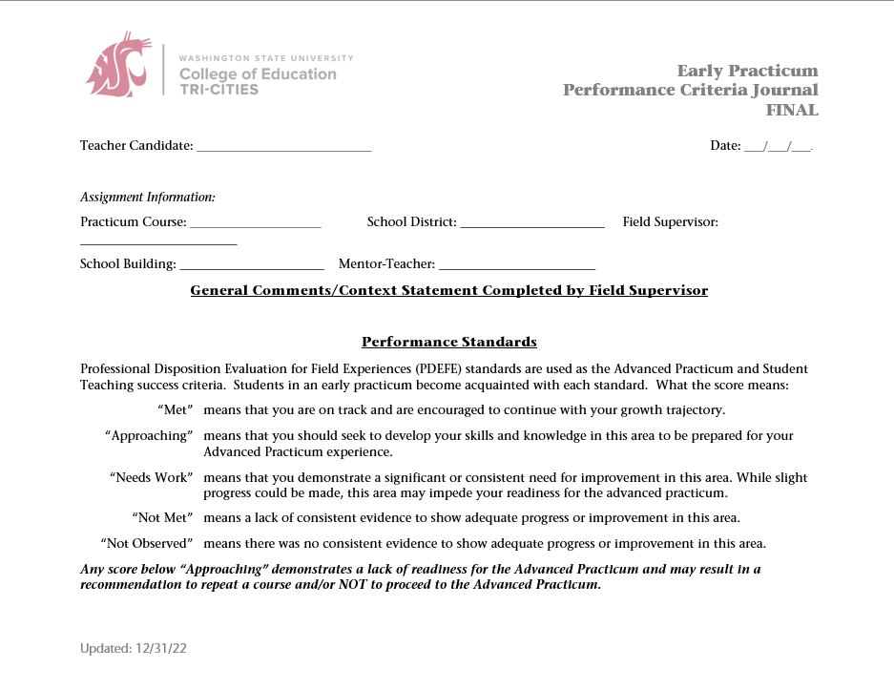
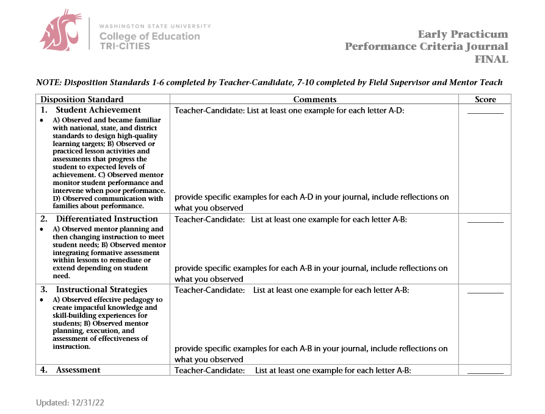
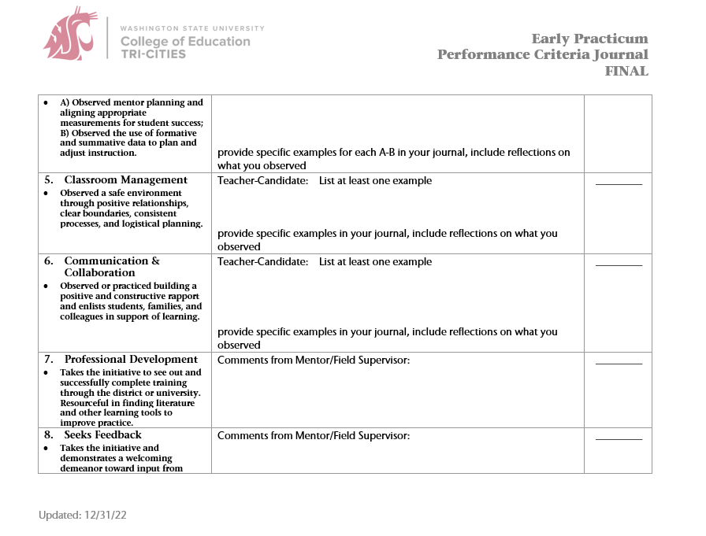
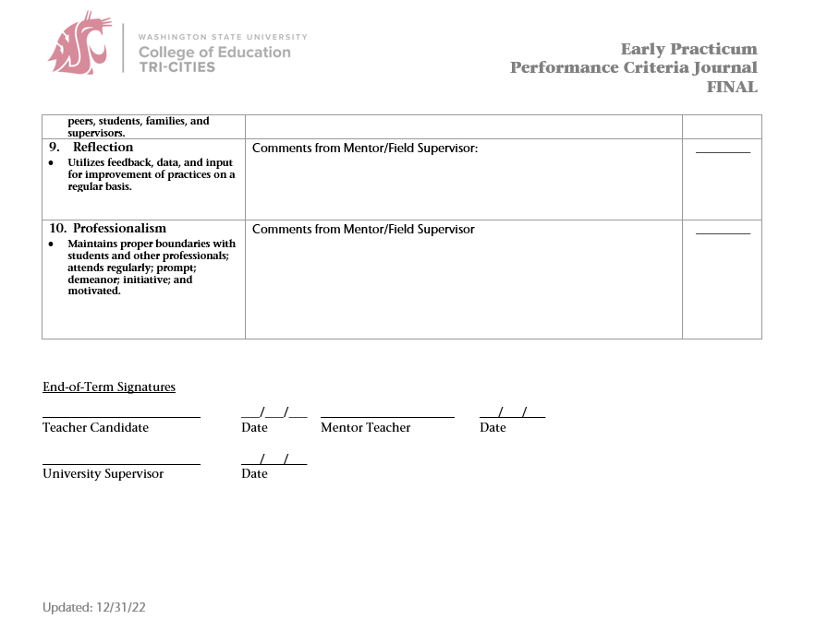
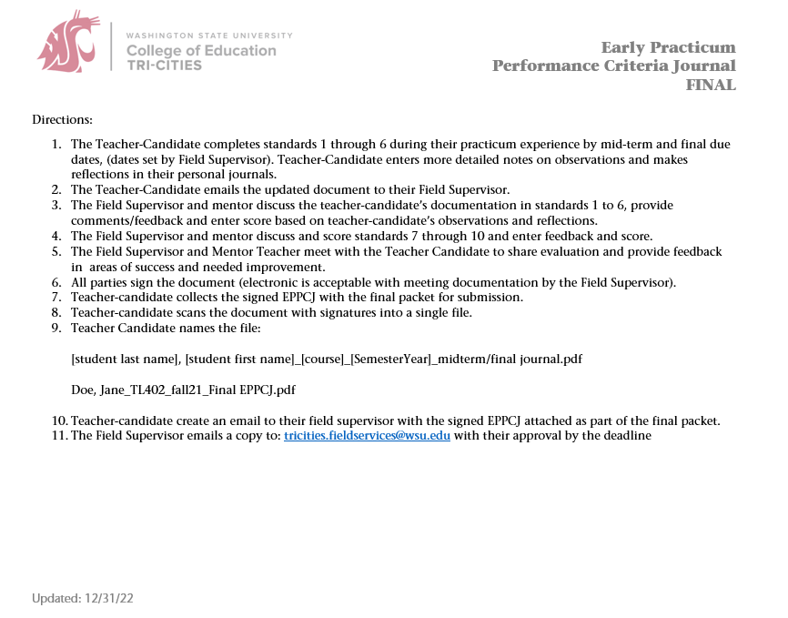

Appendix H: WSU Field Services

WSU Tri-Cities
Dr. John Mancinelli WSU Tri-Cities Field Services Director
O: 509-372-7237 email: John.mancinelli@wsu.edu
Dr. Judy Morrison Academic Director
O: 509-372-7176 email: jamorrison@wsu.edu
Dr. Lindsay Lightner Alternate Route Academic Coordinator
O: 509-372-7366 email: llightner@wsu.edu
Mr. Chris Gana Traditional/MIT Academic Coordinator
O: 509-742-7474 email: cgana@wsu.edu
Ms. Catherine Denham Field Services Program Coordinator
O: 509-372-7135 email: catherine.denham@wsu.edu

WSU Pullman
All mail for the Office of Field Services and Certification should be addressed to:
PO BOX 642114 Pullman, WA 99164-2114. Our Fax number is 509-335-2097
Emily Deen Field Services Director
O: 509-335-xxxx email: emily.deen@wsu.edu
Staci Bickelhaupt Certification Coordinator
O: 509-335-8146 email: sbickel@wsu.edu
Heidi Ritter Program Specialist, Field Services
School contracts, Vouchers, Clock Hours, Travel Reimbursements
O: 509-335-0925 email: hritter@wsu.edu
Tricia Benton Program Coordinator, Field Services
O: 509-335-8166 email: tricia.benton@wsu.edu
Guy Pitzer Places and Supervises Student Teachers & MITs in Pullman Area
O: 509-335-4095 email: gapitzer@inlandnet.com
Lori White Pullman Elementary Practicums
O: 509-335-7984 email: whitel@wsu.edu
Francene Watson Pullman Secondary Program
O: 509-335-5015 email: fwatson@wsu.edu
Jim Johnson Pullman Secondary Program and Supervises Student Teachers in Pullman Area
O: 509-432-9336 email: jrjohnson@wsu.edu
Kris Nilsson Fiscal Specialist, Dept. of Teaching and Learning (PO Box 642132)
supervisor Appointments and Payroll
O: 509-335-5027 email: knilsson@wsu.edu

College of Education Leadership
Karen Thomas-Brown Dean, College of Education
O: 509-335-4853 email: karen.thomasbrown@wsu.edu
Phyllis Erdman Associate Dean for Academic Affairs, College of Education
O: 509-335-4853 email: perdman@wsu.edu
Tariq Akmal Chair, Department of Teaching &Learning
O: 509-335-7296 email: takmal@wsu.edu
Angie Hammond Director, Office of Undergraduate Education
O: 509-335-4855 email: angiehammond@wsu.edu

