MEMO

From: Ray White & Robin Stanco
To: All Campus
Re: Budget Update
Date: February 8, 2019

We are just over half-way through our current fiscal year and getting ready for the next. With this memo, we hope to…
- share our progress towards this year’s budget targets,
- provide a preview of next year’s budget outlook,
- describe the budget calendar and development process we’ll be using, and
- explain how you can participate and stay informed along the way.

This year’s budget targets – For this year’s budget, each department was asked to hold their spending to last year’s levels (FY2018). Additionally, the chancellor’s office has scrutinized every vacancy, replacement and new hire to create savings wherever possible.

As President Schultz and Chancellor Haynes work to balance the budget for the whole system, the Tri Cities campus was charged with meeting a budget target this year (FY2019) of -$400k. Looking at our ‘burn rate’ as of December 31, and thanks to the efforts and sacrifice of all of you, it appears that we have a good shot at achieving this target. Thank you.

Next year’s budget outlook –
While it is still very early in the year to make meaningful predictions about revenues and expenses for 2019-20, here are a few observations
- Compensation – We will not know if there will be a State-funded salary increase until the 2019-2020 Biennium Budget is approved by legislation.
- Tuition Rates – Currently we are not aware of a tuition increase. (Non-resident undergraduate and graduate tuition rates have not been adjusted for several years.)
- Enrollment Trends –After several years of enrollment increases, our Fall 18 enrollment stabilized with a 3% decrease. While we are awaiting spring census results, it is too early to predict enrollment for the 2019/2020 academic year.
- Budget Targets – Our WSU President’s Cabinet Financial Recovery Plan target is BREAKEVEN.
- Other – We will continue to defer non-critical facility maintenance and operations and we are committed to fully funding our Nursing and Advancement departments.

Budget calendar and development process – In the future, our budget process will begin in September of the year prior to implementation. This will allow budget priorities to be informed by our strategic and operational planning. The new process will rely on timely communication, transparency and complete inclusion. At the Chancellor’s direction, we will work with the campus community to build and implement this new process in the fall. But it won’t be ready for our work this year. So…

We’re going to do the best we can with the time we have remaining to meet our objectives of transparency and inclusion to develop next year’s budget (FY2020). This timeline shows our proposed activities between now and mid-May when a final draft budget will be submitted to Dr. Haynes for adoption.

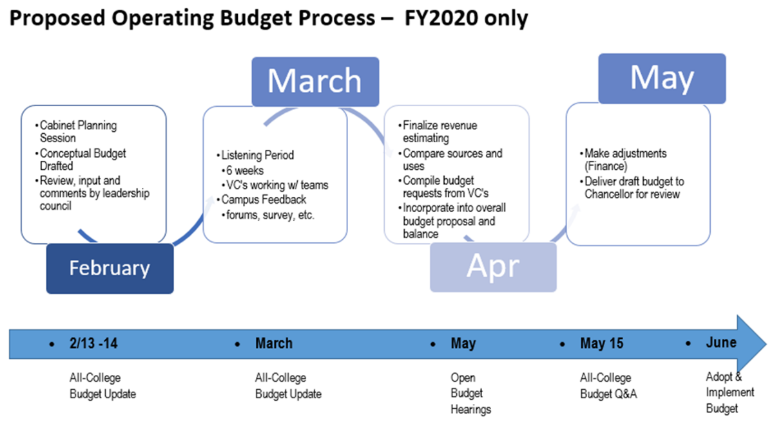

- This month, the Chancellor will create a conceptual budget that will reflect her expectations and priorities for the upcoming year. This will be helpful guidance as we work through the formal budget development.
- In March, vice chancellors will work within their areas to find efficiencies, identify new demands, and consider the reallocation of resources in their areas. Your participation will be particularly valuable during this period.
- Next, area budget priorities will be shared and compared at cabinet. And from this work, the finance team will compile a draft budget.
- In April, the campus community will have additional opportunities to make comment and share concerns.
- There will be at least six all-college activities to share information and solicit campus feedback. Please make time to attend these and voice your concerns.

How you can participate and stay informed? – Yes. We will need your good ideas and feedback in the coming months.
- Attend the budget updates. The first of these have already been scheduled…
  - February 13th from 12-1pm in CIC120, and
  - February 14th from 3-4pm in the East Auditorium 266
- Participate in conversations about resource allocation in your area. Provide your ideas, priorities and concerns to your supervisor and/or VC for consideration as the area requests are being compiled and considered.
- Listen to the rationale for budget requests at budget hearings. Ask good questions and provide feedback. (We’ll try to organize these by topic so you can attend those that meet your interests and expertise.
- When the draft budget is complete, it will be posted and presented in a final forum. Bring your questions and make your comments in person, via email or online.
- Invite Robin Stanco and/or Ray White to come and talk to your department or visit them in-person with your questions and concerns.
- Watch for more updates.

